Cartella stampa
Press kit

Created on 08.09.2017

Biografia
Matteo Fieni, Lugano 1976.

La sua ricerca artistica è contraddistinta da approccio intuitivo, spirito sperimentale e metodo pragmatico. Matteo indaga sia gli effetti del medium fotografico sulla percezione umana, sia le sue caratterische inconsce, combinandone i discorsi di svariata natura in progetti formali, volte a realizzare nuove esperienze visive.

Pedestrian Flow (2016)
Pedestrian Flow (flusso pedonale) nasce dall’osservazione degli spazi urbani e del loro utilizzo da parte dell’utenza pedonale/stradale. Immagini geometriche che astraggono le tracce del passaggio, accentuate dall’effimero strato di neve posato su Lugano il 5 marzo 2016.

Documentazione supplimentare:
mailto:expo@cameraf.ch

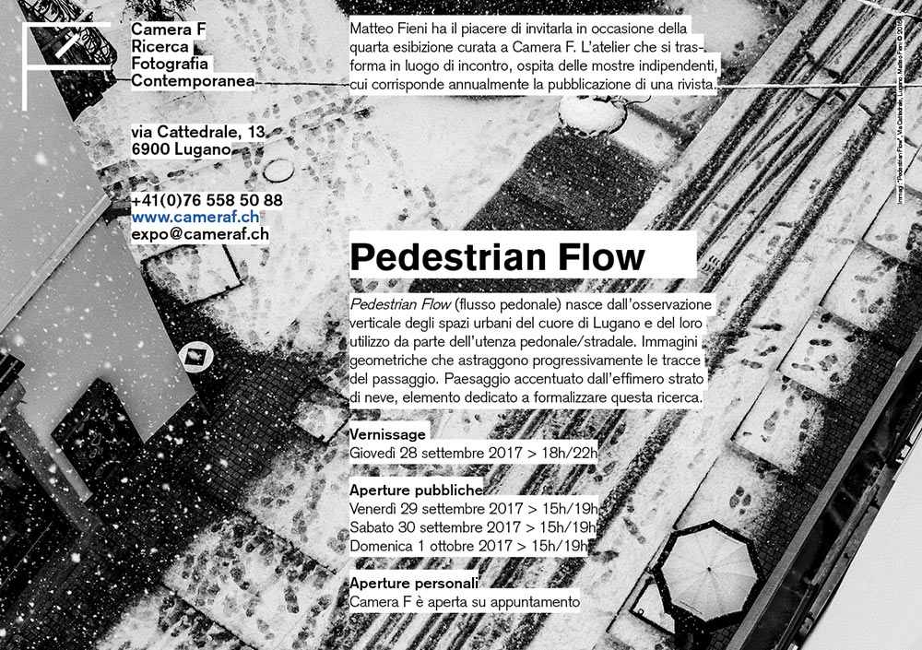

Biography
Matteo Fieni, Lugano 1976.

His artistic research is characterized by an intuitive approach, an experimental spirit and a pragmatic method. Matteo investigates both the effects of the photographic medium on human perceptions and its subconscious characteristics, by combining various types of discourse into formal projects to create new visual experiences.

Pedestrian Flow (2016)
Pedestrian Flow emerges from the observation of urban spaces and their usage by pedestrians in Lugano (Switzerland), on a day in which the fallen snow had not been removed from the streets. The images are taken from above, with a telephoto to allow the compression of the layers and to add to the research of geometrical perspectives, the one of the movement canals used by people and vehicles, which appeared on the ephemeral layer of snow.
This series develops over a short period of time, only a couple of hours before the snow had melted, but allows the viewer to alienate from the documentarist context in order to let a new world emerge, taking some distance from the start of the series, which originally included 24 elements. Pedestrian Flow is a study which had been conceived a few years a got. It has been made entirely on March 5th 2016

Documents:
For nice resolution images (courtesy copyright)
mailto:expo@cameraf.ch

